**Module Title**

**Internet Technologies**

**Assessment Weightage & Type**

**60% Portfolio Coursework**

**Year**

**2024-25**

**Student Name: Osama Jat**

**UWE ID: 24030174**

**Assignment Submission Date:**

**Week: 7**

Exercise-1

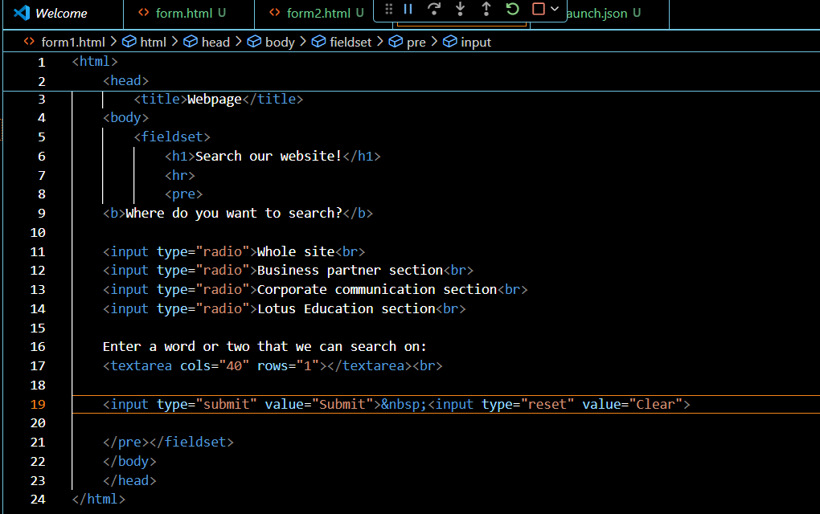

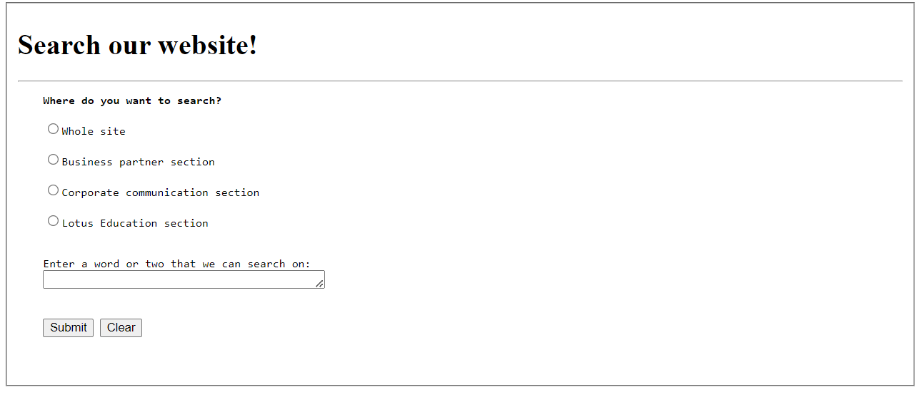  
  
  
  
  
  
  
  
  
  
  
  
  
  
  
  
  
  
  
  
  
  
  
  
  
  
  
  
Exercise-2

